Ushers - Creating an Extraordinary Welcome!
Welcome to the Usher Ministry!

Romans 12: 13
“Share with God's people who are in need. Practice hospitality.”

Thank you for your willingness to respond to the call to usher and serve others. The role of church usher is an awesome responsibility in growing the Kingdom of God. When people appear on the church doorsteps, God is at work. The hospitality and friendliness shared by ushers and greeters helps to usher in the Holy Spirit as worshipers seek to build a closer relationship with God through worship. It is our hope that your ministry will seek to offer an extraordinary welcome as even strangers show up your doorsteps.

OVERVIEW of THE USHER MINISTRY
Church ushers serve with an extraordinary welcome by providing a warm and safe atmosphere to usher in God’s presence. The Usher Ministry serves the people and creates an atmosphere for hospitality. Ushers are simply “doorkeepers for the house of the Lord.”
Ushering provides an opportunity for you to give God’s best. If you think ushering is simply taking someone to their seat and collecting the offering on Sunday morning, you may need to broaden your thoughts. At many Masses, ushers set the tone for welcoming. Ushers provide the friendly smiles, warm greetings and communication that demonstrate Christian love from the moment guests appear on the congregation’s doorsteps.

THE FIRST PERSON GUESTS MAY SEE

An usher or greeter may be the very first person newcomers meet face to face. In other words an usher or greeter may be the first point of human contact for a newcomer. A smile, handshake or simply a kind word may be the sign that guests need to see the joy of being Christian. Although there are many duties of the usher, practicing hospitality should be one of the priorities.

WHY WELCOMING MATTERS
Sometimes congregations underestimate the value of welcoming when preparing for Sunday morning worship service. Sometimes more focus is placed on whether there will be cookies after church at coffee hour while possibly overlooking the possibility that guests may be seeking a place where they can find hope, peace and a spiritual connection. If more congregations were to recognize the value of a smile and a friendly hello, they would more likely communicate the love of Christ in a compelling way that more effectively reaches strangers in the midst of the church family.

What happens during the first 4-8 minutes of a visit to your church?
EARLY MOMENTS MATTER
Research studies indicate that people make up their minds whether they will return to a church within the early moments of a visit. Some studies indicate between 4 to 8 minutes people decide on whether they’ll return. How welcoming your church appears may make a difference in whether a complete stranger returns the following week. The things that matter most include how people were welcomed during those early moments.

Usher Duties--
Before Mass Begins:
- Arrive one-half hour before the start of the mass.
- Ushers greet worshippers making every attempt to help them feel welcome and at ease.
- Greet by name when possible. If you don’t know someone, introduce yourself by name and get other person’s name. Shake hands if offered.
- Be available to answer questions of anyone needing assistance.
- Be alert for guests. Try to introduce them to an existing member of the congregation.
- If someone gives you a birthday request, pass it along to the Pastor before Mass begins.
- Distribute hymnals and bulletins.
- Distribute Children’s Bulletins and pencils to children.

During Mass:
- Direct latecomers into the worship space at appropriate times—preferably NOT during a prayer or in the middle of a reading. It is best to enter the worship space when people are beginning to sit or stand, or during a hymn.
- Be alert for any emergency that may arise. Attempt to relieve the need or contact the person(s) needed to provide the proper assistance.
- Know where the defibrillator and fire extinguishers are.
- If Hospitality will be Served after Mass: During the final Hymn, please move the Hymnal Cart into the Worship Space near the holy water to attempt to relieve congestion in the hallway following Mass.

Preparation of Gifts – Both ushers are needed for this activity. As the hymn/music begins, using the center aisle, pass out the offering baskets and collect at the end and return to the back table where the family/individuals will be waiting to carry the offering to the Priest. Line up in this order: 1) Ushers with baskets, 2) Wine and 3) Bread. Then Proceed towards the altar, after Father takes your baskets move to the side allowing room for the family/individuals to move forward in the center.
After the offerings are gathered, the ushers will go back down the center aisle following the family.

Special Services - If it is a high attendance Service such as Easter or Christmas Eve, have extra folding
chairs reserved in the storage room.
Provide parking lot attendance and assistance when needed.
Escort members and guests to their seats when the church is full and seating is limited with other ushers looking for open seating.

After Mass:
- Clean off/under all chairs—recycle bulletins left in chairs and return hymnals to the rack.
- Check for lost items and if any are found, bring to the parish office and leave a note.

Please be aware of the following items dealing with safety –
• Do you know where the fire extinguishers are? (By Entrance Doors, Near Food Shelf Collection Bin, Kitchen, Utility Room and upstairs)
Remember “PASS” – Pull the ring, Aim at the base of the fire, Squeeze the handle, and
Sweep across the base of the fire from a low angle.
• We have First-Aid Kits in the Kitchen and upstairs.
• Telephones are in the offices as well as in the kitchen. Do not hesitate to call 911 in the
event of a medical emergency, a fire, an accident, or a misbehaving or suspicious person in
the building. 911 from the Parish Center Kitchen or Office phones will take your call directly to Campus Security, which is our first line of action. If you dial 911 from your cell phone it will delay first responders.
• If the fire alarm sounds, or any other indication of fire, smoke, or gas smell, evacuate the
building immediately. This is critically important, as many people tend to sit and wait to see
what happens.
• Be sure all exits are clear and usable. Please check this at the start of your mass time. (Do not add chairs in front of exit doors or high traffic areas.)
- If during the service something irregular should require your attention, handle it with tact and common sense. If someone gives you a prayer request, pass it along to a Pastor. If someone requires medical assistance, direct someone to call 911 if necessary and in the meantime, find a doctor or nurse from the congregation to help. (Janet Kociemba, Mitzie Brinkman, Therese Wallner, Kari Scholz, Rebecca Hafner & Eileen Haeg are some of these people.) Do not overlook the defibrillator in the main hallway on the wall above the food shelf collection bin in the event something looks like cardiac fibrillation. The machine itself will instruct you; it will not “fire” unless it is necessary; this means you cannot harm someone by using it. There is also a blood pressure cuff in the cabinet with the defibrillator.

Thank You for your service; and Thank You for keeping everyone safe!

**What if I cannot Usher as scheduled? If you are unable to attend the Mass you are scheduled to usher at, please find a replacement. If you cannot manage to find your own replacement then contact the Usher Coordinator (Tim Koltes) and he will find a replacement for you.

July 1, 2016 Usher List:

Bob & Alice Mayers

Heidi & Mike Peternell

Brian Eisenschenk

Gene Eisenschenk

Clarence & Shirley Simon

Pat & Joan Pfannenstein

Jerry & Lois Rothstein

John Melancon

Elaine Vogel

Terry & Laurie Malikowski

Chuck Lauer

Bob Simon

Ken Schmitt

Dan & Julie Ortloff

Jan Faulhaber

Marlin Faber

Robert Brinkman

Ron & Char Eisenschenk

Carol & Lee Wolf

Sacristans - Guardians of the Eucharist

Sacristan Coordinator: Chuck Lauer 320-266-5023
Welcome to the Sacristan Ministry! We hope you find this to be a very rewarding and meaningful ministry and enjoy making our liturgies go as smoothly as possible for our fellow parishioners. Below is a list of frequently asked questions regarding the sacristan ministry as well as the contact information for the coordinator of the sacristans should you have additional questions.
What does a sacristan do? As Sacristan, we have three main roles: Security--(of the sacristy and most importantly, the Eucharist), Mass Set Up and Clean Up, and Mass Coordinator. You will serve all three roles each time you are a Sacristan, though some of the roles may play a bigger part than others, depending on the mass. Below is a brief explanation of each role:
Security: We are responsible for assuring proper treatment of the Holy Species, namely that of the Sacred Blood and Blessed Sacrament during and after the celebration.
Mass set up and clean up: At every mass, you are responsible for setting up for Liturgy of the Eucharist which means preparing all of the vessels, gifts, and incense when appropriate.
As mass coordinator, a sacristan also assists the presider with whatever details/duties he needs done. The sacristan will check to make sure the altar servers are ready and in place as well as making sure the assigned lectors and Communion Ministers are present and ready to serve.
How often do I serve?
Depending on the number of sacristans assigned, you may serve once a month or more infrequently. You can choose to serve at either Saturday night or Sunday morning masses.
What's the time commitment?
Generally, the time commitment is a half hour before and a half hour after your mass. That may vary depending on the particular mass you serve and how fast you work. As you get accustomed to the duties, you are generally able to go a little faster.
Are there meetings?
Our only meetings are when there are changes to our routine or when called for by our pastor. There will be a training session for all the new sacristans.
Whom should I contact if I have more questions?
Feel free to speak to any of the sacristans that serve at our masses and talk with them about their experience as sacristan. If you have any further questions, please contact Chuck Lauer
Requirements:
- a registered parishioner
- Confirmed Member
- wish to serve God
Interested in becoming a Sacristan? Contact the Parish Office to sign up 363-2569.

SACRISTAN’S RESPONSIBILITIES
Be at church at least 20 minutes before our assigned Mass.
If you are unable to be present at your assigned Mass, PLEASE get a substitute. If you are unable to find a replacement, contact Chuck Lauer’s cell: 266-5023 and he will find a replacement for you.

Set-up procedure for Mass
- Count the chairs in the Sanctuary. As of January 1, 2017 there are 161 Red Chairs set up for Saturday Mass. If more seating is needed, there are folding chairs in the storeroom.
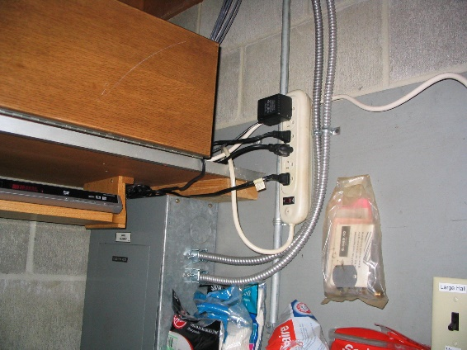
- Turn on the sound system (turn on the switch on the power strip located in the utility room of the kitchen [see photo]). Check who will be providing the music for mass; make sure that they have the appropriate items set up. (Piano/Guitar, cantors require one tall microphone, chairs and music stands. TEST that all microphones (music and ambo) are working.

Gather the following supplies:
- Collection baskets (5) are kept in the upper kitchen cupboard to the left of the toasters.
- Gather the following items from the drawers next to the vestment closet and from the kitchen counter and place on table near patio door:
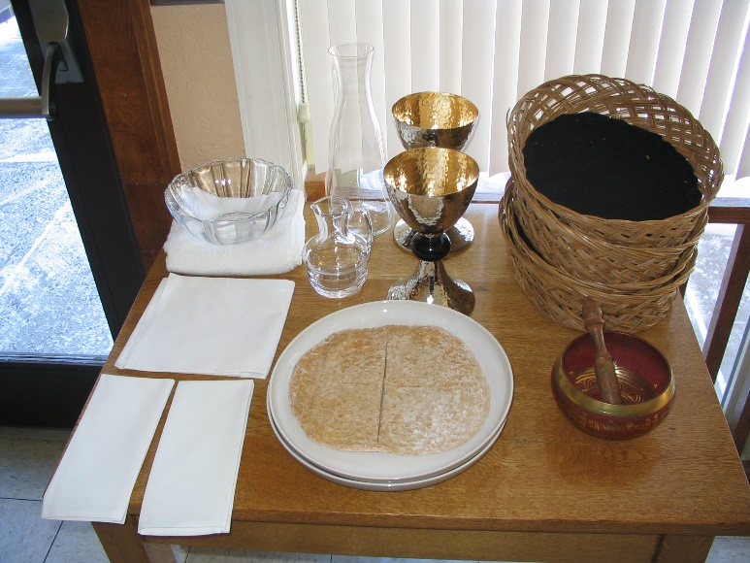
- Ziploc bag of communion bread from the kitchen cooler.
- 2 purificators,
- 2 chalices,
- 2 gray plates,
- 1 white hand towel,
- 1 corporal
- Lavabo (glass dish for hand washing),
- Large glass wine decanter,
- small glass cruet for water
- the singing bowl

NEW! Gluten Free Communion notes:
If a mass attendant needs a Gluten Free(GF) Host they need to inform the Sacristan, and the Sacristan should follow the following instructions:
There is a container labled “Gluten Free Hosts” in the Cooler, where the communion bread is kept. If someone needs a Gluten Free host, simply take a GF Host out of the container (make sure it stays in its plastic bag) and place it on the communion plate under the disc of regular communion bread. Inform the person that their GF Host will be on Fr. Greg’s plate, so they must receive communion from him.

*it is most important the GF Host be enclosed in plastic at all times so that it doesn’t become contaminateed the regular communion bread.
**It might be helpful to notify Fr. Greg before mass that there will be a GF Host on the plate.

- Place the following on the credence table behind the altar: The 2 matching Chalices, two purificators (rectangular cloth folded in thirds), white hand towel, one gray plate, the cruet with water inside (Fill the water cruet with tap water with about 2” of water), the Corporal and Lavabo. [see photo below]
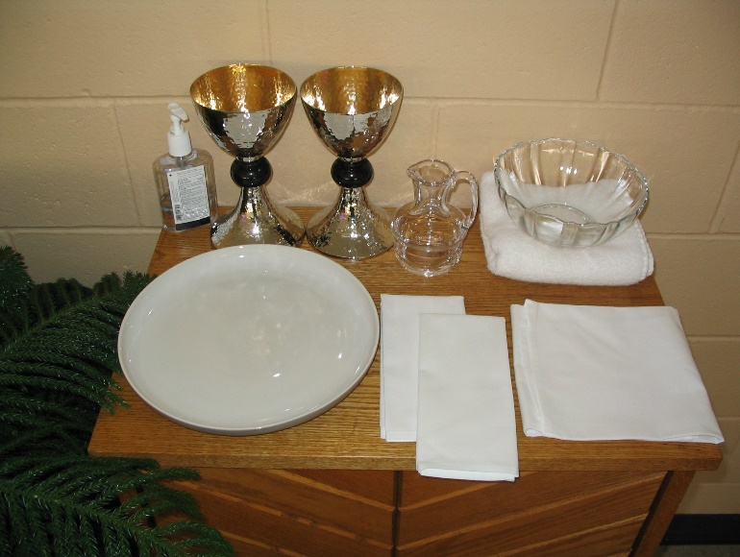

-Please place a fresh glass of tap water by Fr. Greg’s chair.

- lighters can be found inside the altar).

- The Tabernacle is permanently placed in Mary Chapel behind the screen, the key is in the Chalice drawer.

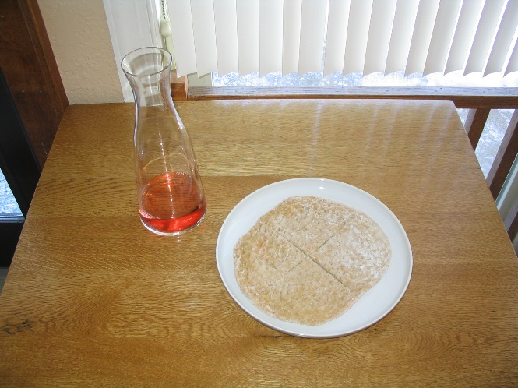

On the table by the patio door; fill the wine decanter with wine from the refrigerator (1 Cup for Saturday mass (there is a measuring cup in the mini-fridge by the wine). [with clean hands] place the loaf of communion bread on the large gray plate. Each disc of bread can tear into about 75 pieces, put whatever amount needed based on the number of people at mass (loaf and a half). Put the half or wedge under the large whole disc on the plate. The un-used ½ disc needs to be put back in the freezer. These items will remain on the table for the presentation of gifts:

Presentation of the Gifts: Not everyone needs something to carry, to be a part of the presentation is important. Order to process:
1.ushers with baskets,
2. wine,
3.then bread.

- Light and extinguish all the candles.
- Make sure that the scheduled Gift Bearers are present to give the bread, wine and collection to the priest. Explain to them that they should come to the table by the patio doors after the ushers have passed them with the collection. They should then wait at the table until you give them the cue to bring the gifts to the priest. (You should go back to the table also, to help assist the family and to cue them). If the scheduled gift bearers are not present, please find another family or group to replace them.
- The communion ministers, the lectors, the ushers, and the servers are supposed to sign in by checking off their names from the Liturgical Ministry List near the kitchen door. If you can, please make sure that all positions are accounted for. Try to get substitutes when needed - especially servers and lectors. (Let the priest know if anyone is missing.)
- IMPORTANT: On the bottom of the Liturgical Ministry Check-In List is a blank line to fill in with the entire number of people attending Mass; please count and fill this number in.
- Please sit, if possible, near the back of church, if your services are needed (adjusting thermostat, sound system, etc.) during Mass, you can get up easily and discreetly.
- To adjust the thermostat: simply adjust the arrows up or down to the desired temperature (70 degrees in summer and 68 in winter) then adjust the arrows to the right of the time to the time that mass will be over then press done in the lefthand corner. During Mass times: the fan should always be on, not on automatic—turn back to automatic when mass is done. Be sure both thermostats are set the same way.
- If During Mass Fr. Greg’s microphone requires a new battery—they are in the cabinet drawer in the office labeled “Microphone items”
- Try to keep all the kitchen doors closed (especially the pass-through) and the kitchen lights off to avoid distractions.

Clean- up Procedure
- Place used purificators in the white plastic bin on the kitchen counter near the toasters.
- Place used white hand towels on top of the washing machine/dryer in the kitchen.
- Once purified (drink wine, never pour down drain), all chalices, plates, etc. need to be washed with soap and water, dried and put back in their appropriate drawers near the vestment closet. Baskets and singing bowl can be put back in the cupboard above the used purificators.
- Check that all candles have been extinguished.
- Check that all hymnals are put away, and that misc. items (bulletins) are not left behind in the worship space.
- Turn off the sound system.
- Take the collection baskets to the parish office and set it on Father’s desk. (Father will place it in the safe.)
- Turn off the lights in the worship space and check that all exterior doors are pulled shut tight.

July 1, 2016 List of Sacristans:

Arnie Sauerer 320.356.7853
John Brinkman 320.656.7732
Chuck Lauer 320.266-5023 (Coordinator)
Dan Ortloff 320.492.4378
Robert Brinkman 320.363.7820
Bob Simon 320.363.7865
Brian Posch 320.333-2036

Communion Ministers

Communion Minister Coordinator: Wanted: Would you be willing to train in new Communion Ministers?

Your willingness to serve as an Communion Minister, reflects not only a response to your Baptismal call to service, but a commitment to Christ as you share in the ministry of the Eucharist. You offer the Eucharist, recognize the Body of Christ in those to whom you offer Eucharist, and ultimately you act as the Body of Christ by fully participating in the life of the wider community.

Requirements:
Baptized and Confirmed Catholic’s are eligible for this ministry. They should be persons who sincerely try to live the Gospel message in their communal and individual lives.

Before Mass
- Check in with the Sacristan or check-off your name on the Liturgical Ministry list on the door prior to the start of the liturgy.

During Mass
- Immediately following the “Sign of Peace,” line up near the west side of and behind the altar. Please utilize the Hand Sanitizer from the credence table.
- Communion will be distributed to the communion ministers during the “Lamb of God”. The presider will hand each minister the Eucharistic Bread, and ALL will wait and consume it at the Same time as Fr. Greg. Then, each will proceed directly to her or his assigned position to minister Communion to the assembly. Communion begins on the East Side of the church and then proceeds to the West side once BOTH Ministers have completed distribution.
- The Body of Christ is administered with the words, “The Body of Christ”. After the communicant has responded “Amen”, the host is placed in the hand or on the tongue, according to the manner indicated by the communicant.
- The Blood of Christ is administered with the words, “The Blood of Christ”. Ministers should stand an appropriate distance from each other to facilitate the Communion procession and not unduly impede the assembly’s easy movement. After each person has received the Blood of Christ, the minister should wipe the rim of the chalice with a purificator and rotate the chalice slightly before repeating the procedure for the next communicant.
- If a piece of bread falls to the ground during distribution, the minister should pick it up, place it on the altar or consume it.
- When finished, ministers will return their vessels and folded purificator to the credence table, remaining bread can be taken to the kitchen to consume . You do not need to consume all the remaining blood of Christ—simply lay a purificator over the chalice to cover.

**What if I cannot be a Communion Minister as scheduled? If you are unable to attend the Mass you are scheduled to Minister at, please find a replacement. If you cannot manage to find your own replacement then contact the parish office.

April 1, 2017 Communion Ministers:

Bob & Evie Dumonceaux

Patty Dumonceaux

Linda McNair

Nancy Fandel

Deb Symalla

Kelly Haeg

Mike Keable

Elaine Omann

Alice & Bob Mayers

Joyce Abeln

Tess Koltes

Jerry Rothstein

Damien Dumonceaux

Judy Andersen

David Lyndgaard

Dan Ortloff
Lector Guidelines
Lector Coordinator: Scott Wallner: 320-247-9532

“The Lord has given me a well-trained tongue, that I may know how to speak to the weary a word that will rouse them.” Isaiah 50:4

Before Mass:
The most important thing to remember is that preparation is essential. When you are scheduled to lector, we ask that you do the following:
- Read through the selected reading in the lector workbook. The notes in the workbook often provide helpful insights and explanations of the readings. The pronunciation guide can assist you with difficult words or place names.
- Spend some time reflecting on or praying about the reading.
- Practice reading the scripture passage out loud several times until you are comfortable with it.
Please be on time. Arrive at least fifteen (15) minutes before the start of Mass. If you cannot attend a Mass for which you are scheduled, please try to find a substitute. If you cannot manage to find a substitute, please contact the Lector Coordinator and he will find a replacement for you.

Two lectors are scheduled for each Mass. Please prepare for both readings in case the other lector is absent. After both have arrived, the lectors should decide who will act as Lector One and who will act as Lector Two and proceed appropriately (Lector Two reads the prayers of the faithful).

The lectionary can be found on the counter in the kitchen and is generally marked with the ribbon for the day’s readings. The petitions will be in three ring binder on the same counter. Please review the petitions before mass begins. You should also review your reading in the lectionary since it looks different in the lectionary than it does in the lector workbook.

About ten (10) minutes before the mass is to begin, Lector Two should take the lectionary to the ambo. Open the lectionary to the day’s first reading and take the petitions binder to your seat with you. Lectors usually sit somewhere close to the ambo.

About five (5) minutes before the mass is to begin, Lector One should proceed to the entrance of the worship space with the Book of the Gospels to prepare for the opening procession.

During Mass:
At most masses, Lector One is the first person in the procession. After the opening hymn has begun, start processing to the altar with the Book of the Gospels. You should hold the Book of the Gospels at a level in front of you that is comfortable, with the front of the book facing forward. Hold the book in a manner that allows you to NOT have to peek around the book. Please hold the book with both hands and walk slowly and reverently.

When you reach the altar, face it and wait while the presider and the server(s) in the procession form a line. It is not necessary for you to bow for the lectionary and the altar are both symbols of Christ, and one should not bow to the other. When arriving at the altar; if you are carrying the book high above your eyes lower it to your chest. After they bow continue around to the back of the altar and place the Book of the Gospels in the center of the altar FACE DOWN, then bow to the altar and proceed to your seat.

After the Presider concludes the opening prayer and is seated, Lector One walks to the ambo for the first reading. Begin the readings with “A reading from…” not “The first reading is from…” As you proclaim the reading, take your time; make the message clear. Remember, you are proclaiming the Word of God to your sisters and brothers in Christ.

The appropriate conclusion to the reading is [pause… “The Word of the Lord”.] Say this clearly and slowly and with clear invitation for response. Wait until the congregation responds “Thanks be to God” before leaving the ambo. Then return to your seat.

After the Responsorial Psalm, Lector Two walks to the ambo for the second reading. Again, begin by saying “A reading from…” not “The second reading,…” Remember to take your time here as well. After you finish the reading, close the lectionary and place it on the shelf of the ambo and return to your seat.

After the homily and the creed, it is time for the petitions. If the creed is said, Lector Two walks to the ambo with the Petition binder during the last paragraph of the creed. This paragraph begins with “We believe in one, holy, Catholic and apostolic church…” If there is no creed said, watch the Presider carefully to determine when to approach the ambo to read the petitions. After the Presider says the opening prayer for the petitions, read the petitions slowly and clearly.
On the fourth Sunday of each month we read a petition for the names listed in our “Prayer Corner”. Please read the names slowly and clearly, if you need help with a pronunciation, please ask someone (Father or sacristan) before mass begins.
The conclusion to each petition is usually “We Pray to the Lord”, to which the congregation responds “Lord Hear Our Prayer”. Stay at the ambo until the Presider has said the closing prayer for the petitions, then return to your seat.

The Lector(s) do not process out with Father and the Servers at the end of mass, rather the book of Gospels stays in the worship space.

After Mass:
Lector One should return the Book of the Gospels to the counter in Parish Office. Lector Two should pick up the lectionary and the petitions binder and return them to the counter in the Parish Office.

July 1, 2016 Lectors:
Evie Dumonceaux Nancy Fandel Eileen Haeg Sharon Beach
Mike Keable Scott Wallner Isaac Hansen Nick Hansen
Mary Reischl Tess Koltes Dave Lyndgaard John Melancon Tom Wicks Greg Hansen

Mass Server Guidelines
Mass Server Coordinator: Mary Reischl 363-7831

Welcome!
You are now a member of a very special group of people in our parish who have answered God’s call to ministry. As a St. John the Baptist Parish Mass Server, you are one of the liturgical ministers of our parish.
Liturgical ministers have special tasks to perform during liturgies, especially during the celebration of the Eucharist (the Mass). The Altar Server is very important in helping God’s people worship in the best possible way.

Introduction
Serving is not for everyone. It is a call from God to a special ministry in the Church. As a Server, you are a Liturgical Minister with an important role during the Mass or during other liturgical services, such as Stations of the Cross or Benediction. Remember that you are always part of the congregation even if you are sitting in a different place than they are.

Requirements for Altar Server Candidates
- Must be in the 3rd grade and must have made their First Communion.
- A strong desire to serve at the Altar of Our Lord and Savior, Jesus Christ.
- Know how to make the Sign of the Cross.
- Know how to receive Holy Communion.
- Be willing to pray aloud and make appropriate responses during the Mass.
- Be punctual, meaning being at church at least 10 minutes before Mass starts.
- Stay alert and attentive during Mass to serve the priest.
- Function without attracting attention away from the Mass.
- Wear appropriate clothing to church for serving even if you are not scheduled as you could be needed as a substitute.
- Be able to work together as a team.
- Be well rested and fed before you come to serve.

Training
Training is required before you are eligible to serve. You will receive appropriate training to get you started. During the training you will learn some basic information about the Catholic Church and the Mass. You will also learn how to carry out specific tasks while serving at the Altar. After training, you will be assigned to serve for several times with an experienced server until you feel comfortable with your role as a server.

Standing
Always stand up straight with both feet firmly on the floor. This will give you balance and comfort, especially if you have to stand for a prolonged length of time. Don’t lean against walls or furniture.

Sitting
If more than one Altar Server is serving, the servers should wait until all of you are standing in front of your chairs, then everyone should sit down at the same time.

Eyes
During Mass always look toward the place where the action is: the celebrant’s chair, the ambo or the Altar. When the lector is reading, you should look at the lector. When you are talking to someone, you are expecting the person to look at you – the same is true at Mass.

Mistakes
When you make a mistake (and we all do) never get flustered. Everyone makes an occasional mistake-but it is best to just move on and continue along as though whatever happened was deliberate-don’t get flustered.
Smoothly and quietly take the next opportunity to set things right. Get into the habit of keeping an eye on the action at the altar. That will help make you aware if the Priest is trying to get your attention to take care of something you may have forgotten or some unexpected task.

Before Mass
Be sure to dress properly for serving Mass (no shorts). Check your name off of the Liturgical Minister sign-in sheet. Gather by the kitchen door and be ready to start Mass by ringing the singing bowl. Remember to be reverent, alert to what Father needs, and fold hands when not holding something.

THE ORDER OF MASS
The Beginning of Mass
Just before Mass is to begin, the Altar Servers should wait prayerfully near the kitchen door. When directed by the priest, strike the singing bowl three times. During the 30 seconds of silence, the server should return the singing bowl to the table by the patio door. Then line themselves in the correct order to be ready for the procession.
Procession Entrance
The Lector goes first, followed by a server, the second server and then the priest. Walk up and form a line in front of the Altar.
Father
Server
Lector

Server
Chair
Father’s
Chair
Server
Credence Table
Server
Chair

Ambo
Altar

Servers should bow when Father bows. Father will kiss the altar and then go to the presider’s chair, the server(s) will proceed to his/her chair. The Altar Servers remain standing at their chairs.
Greeting and Sign of the Cross
The Priest will begin by making the Sign of the Cross along with the whole assembly – all of the Altar Servers join in making the Sign of the Cross and responding with the Amen.

Penitential Rite
The Priest invites the assembly to reflect on their sins and then the Priest leads the congregation in penitential prayers which are followed by “Lord have mercy”… “Christ have mercy”… “Lord have mercy”… Altar Servers are to join in these responses.
The Gloria
The Gloria (Glory to God in the Highest…) is sung or recited on Sundays, solemnities, and feast days except during the season of Advent or Lent when it is omitted.
Opening Prayer
The Book Bearer brings the Missal (book) to Father (when these words are heard, “Let us Pray”) by holding it in both arms right side up so that Father can open and read it. Stand slightly off to the side, not directly in front of Father, and always let Father close the book. At the end of the Opening Prayer, the people and all Altar Servers respond “Amen”. When Father closes the book, return to your chair with the book.
The Liturgy of the Word
The focus of the action now shifts to the ambo. The Altar Serves’ attention shifts with the action. Look at and listen to the Lector.
First Reading
The Lector begins with “A reading from the book of…” At the end of the reading, the Lector says “The Word of the Lord”. The Altar Servers respond aloud, “Thanks be to God”.
Responsorial Psalm
The Cantor or Lector will lead the people in the Responsorial Psalm by reciting or singing the response after which the Altar Servers respond appropriately with the Psalm Response with the congregation.
Second Reading
When there is a second reading (Sundays and solemnities), the Lector begins and ends as with the first reading. The Altar Servers respond aloud with the congregation, “Thanks be to God”.
Gospel Acclamation (Alleluia)
Except during Lent, the Gospel Acclamation is the singing of the Alleluia. (During Lent a different acclamation will be sung). All Altar Servers stand and sing the Alleluia with the congregation.
The Gospel Proclamation
The Priest will begin by saying “The Lord by with you.” All Altar Servers respond aloud with the congregation, “And with your Spirit.” Then the Priest traces the small Sign of the Cross on his forehead, lips and heart, all Altar Servers do the same thing. The Gospel ends with “The Gospel of the Lord.” to which all Altar Servers respond aloud, “Praise to you Lord Jesus Christ.”
The Homily
A homily or teaching on the sacred scripture will be given, during which the Altar Servers are to pay close attention to the Homilist and are not to fidget or begin looking around. The Altar Servers are to remain still, quiet, and pay attention what the Homilist has to say.
The Profession of Faith (the Creed)
After the homily, there will be a brief period of silence while everyone meditates on the message given by the homilist/Priest. Then the Priest will stand and all Altar Servers will stand. When the Priest begins reciting the Creed, all Altar Servers will recite the Creed aloud with the Priest and congregation.
The Prayer of the Faithful (General Intercessions)
The Prayer of the Faithful is the collection of prayers read from the three-ring binder for the intentions of the Church, public authorities, the sick, the local community and the dead. Each petition will end by the Altar Servers and the congregation responding aloud, “Lord hear our prayer.” At the conclusion of the General Intercessions, the congregation is seated and the Altar Servers prepare for the Liturgy of the Eucharist.

The Liturgy of the Eucharist
Preparation of Gifts
Immediately after the Prayer of the Faithful, both servers go to the credence table and bring the Corporal to the altar and open it, then on the right side of the altar place the chalices, cruet of water and purificators. Return to your chairs and wait for Father to get up and receive the gifts. As you move forward to accept the gift, one server takes the missal and places it on the corporal on the altar.
Receiving the Gifts
The Servers will now focus on the Priest and on the people who bring offerings of Bread, Wine and the collection to the Altar. Father will hand you certain gifts – money basket, cruet of wine, or dish of bread. Let Father go to the Altar first. Place the money baskets on the floor in front of the Altar. The Server with the wine stands at the side of the Altar and holds it until Father takes it—never place it on the altar.
Next, get the Lavabo (bowl), towel and return to the Altar for the washing of Father’s hands. When finished washing, Father will bow to the servers, both servers should bow back at the same time. Servers then return to their chairs and remain standing.
Prayers over the Offerings/Preface Eucharistic Prayer (Consecration)
At the end of the “Holy, Holy, Holy…” Eyes (and minds) are focused on the action at the Altar. Father puts his hands over the gifts and asks the Holy Spirit to change the bread and wine into the body and blood of Christ.
Sign of Peace
The Altar Servers exchange the Sign of Peace with Servers next to them.
Communion
Servers bring the gray plate to the Altar. The Communion Ministers will come up to the Altar, as soon as Father finishes with, “Lamb of God who takes…” go to the credence table and take the hand sanitizer and give a squirt to each of the Communion Ministers. The Priest will divide the bread between the two gray plates. Servers should line up with the Communion ministers to receive communion. Servers will assist the communion ministers by holding the gray plate under the bread (from tearing to hand) during distribution.
After Communion
Help clear the Altar. The Server should refold the corporal and place it on the credence table. Return everything to the credence table except for the Missal (book) which will be returned to the chair of the Book Bearer.
Concluding Rites (Closing Prayer)
When Father says, “Let us Pray,” the Server with the Missal (book) returns to Father in the same manner as in the opening prayer and remember to let Father close the Missal. After prayers is complete, return to your chair and remain standing.
The Recessional
Immediately after the Blessing. The Priest will move to the Altar and reverence it with a kiss which is the signal for the recessional. The Altar Servers go to each side of Father. When Father bows, the Altar Servers bow and then turn to process out side-by-side. The servers go first and then Father. The Lector doesn’t process out.
Notes:
Servers bow to the Altar at the procession in to Mass and before you process out of the worship area; those are the only two times during Mass which you bow to the Altar.

July 1, 2016 Servers:
Caroline Linz Cole Pfannenstein Bob Simon Jane Simon
Mary Reischl Scott Wallner Sara Koltes Rachel Warner
Elizabeth Merdan Jarred Scholz Nicholas Merdan Mike Keable
Logan Scholz Spencer Scholz Elizabeth Merdan
Holly Hansen Nick Hansen Isaac Hansen

Objects, Places and Names
Here is an alphabetical listing to the names, places and things that Altar Servers might need to know.

ALTAR The holy table upon which the Priest offers the sacrifice of the Mass.
ALTAR CLOTH The white cloth covering the altar.
AMBO The stand from which the Word of God is proclaimed during the Readings of sacred scripture.
ASSEMBLY The Assembly is sometimes called the People of God, the Church or the Congregation. It is everyone seated in the Church who have assembled for worship.
BLESSED SACRAMENT This is another term used for the consecrated bread which has become the sacramental Body and Blood of Christ.
BOAT This is the container for the incense. It is called a boat because it is often shaped like a little boat.
BREAD Refers to the unleavened bread that will be consecrated and become the Body of Christ.
CANTOR The Cantor is the minister who leads the singing and who sings the Psalm responses.
CHALICE The large gold or silver cup that is used by the Priest that holds the wine to be consecrated and become the Blood of Christ.
CHASUBLE The large outer garment worn by a Priest – usually green, violet, white or red depending on the liturgical season.
CIBORIUM A ciborium is a special sacred vessel used to hold consecrated hosts. The consecrated hosts that are unconsumed at the end of Mass are placed in the Ciborium and then placed in the Tabernacle.
CORPORAL The linen cloth, folded to appear square, that is laid out on the center on the altar cloth. The sacred vessels, containing the offerings that are to be consecrated into the Body and Blood of Christ, are placed on the Corporal.
CREDENCE TABLE A Credence Table is a small table used for holding the sacred vessels that will be used during the Mass.
CRUET A Cruet is a small, crystal bottle used for the water and the wine.
GENUFLECT When you genuflect, keep your hands in front of your chest while you go down on your right knee. A sign of reverence.

HOLY OILS The Holy Oils include the Oil of Sacred Chrism and the Oil of the Sick and the Oil of Catechumens. These are special oils that are blessed by the Bishop each year. The oils are then used throughout the year for Baptisms, Confirmations, Ordinations of Priests and Deacons, Consecration of churches and the Anointing of the Sick.
HOST The unleavened bread which has been consecrated and we believe has become the Body of Christ.
LECTIONARY The Lectionary is the book containing the readings from sacred scripture that are proclaimed from the Ambo by the Lectors during Mass.
MISSAL The sacred book used by the Priest that contains all of the prayers of the Mass.
PASCHAL CANDLE The Paschal Candle (sometimes referred to as the Easter Candle) is the very tall decorated candle. It is lit during Baptisms, Funeral Masses and Masses during the Easter Season.
PURIFICATOR The small linen cloth that the Priest uses to clean the Chalice – these cloths are folded into a long rectangle shape to separate it from the Corporal which is folded into squares. Since the purificator will come into contact with the Precious Blood when wiping communion cups and chalices, it is treated with special care and should remain in its folded position during use.
STOLE The stole is a long narrow band of material that resembles a shawl and is the sign of authority of the Priest. The Priest wears it straight down.
TABERNACLE The Tabernacle is the locked wooden cabinet. The Tabernacle is used to reserve consecrated hosts which are the Body of Christ. Because the Tabernacle houses the Blessed Sacrament we pay special reverence to it. A lighted candle (the red vigil lamp) is kept burning near the Tabernacle at all times when the Body of Christ is in the Tabernacle.
THURIBLE The Thurible is sometimes referred to as an incenser, and is a special vessel suspended from chains in which glowing charcoal is contained. The Priest sprinkles incense from the Boat over the glowing charcoal during liturgies when incense is used.

